7th Grade Social Studies Newsletter
Mrs. Kinsey’s Newsletter
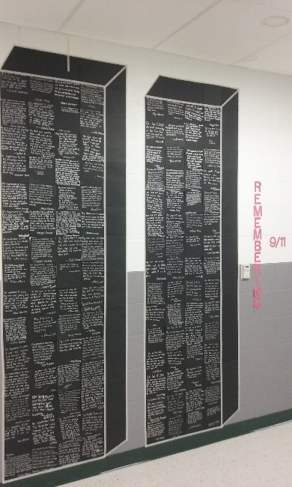

Upcoming Dates

October 6
No School – Teachers’ Institute

October 9
No School – Columbus Day

November 3
End of the 1st Trimester

November 6
Parent/Teacher Conferences – http://signup.com/go/QXvqKXe use SignUp.com to reserve your time

November 9

Half day – 11:00 dismissal @ WMS – Parent-Teacher Conferences – http://signup.com/go/QXvqKXe use SignUp.com to reserve your time

November 10
No School – Parent-Teacher Conferences– http://signup.com/go/QXvqKXe use SignUp.com to reserve your time

W: http://melissakinsey.weebly.com/ T: 309-444-3361
WOW! It is hard to believe that it is already October! August and September flew by, but students have been hard at work in all of their classes. If you have any questions about Social Studies, please contact me Mrs. Melissa Kinsey at d52mkins@d52schools.com.

What we have been up to!
We started the year with our All About Me project. I loved seeing all the pictures and creativity that students put into this presentation. If you haven’t seen your child’s presentation, ask them to show you it.
We took some time to learn about September 11, 2001 and the events that took place that day. In addition to viewing Inside the Twin Towers, students interviewed someone to find out what they remember about September 11. At the conclusion of our documentary and discussion students wrote a memory square that was placed on our memorial wall at WMS. Pictured above.
We also discussed the colonization of North America. Students learned various reasons why settlers came to settle in the Americas (monetary reasons, religious reasons, and for more opportunities). Student understanding has grown with the use of readers’ theaters, videos, the textbook, essential questions, and chapter projects. Student work is stored in their Social Studies binder; ask to see it.

More to Come
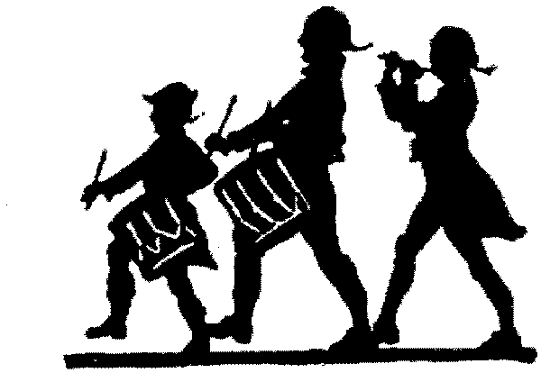

How You Can Help!

Study I CANs together
The I CANs are the study guide to the test. Students complete part of the I CANs after reading a section of the Chapter. If you study with your child, sign their I CANs for extra credit.

Quizlet
Students can use quizlet to review a section’s important information. You can review this information together by playing a game or taking a practice quiz.

Check grades
Grades are posted multiple times through the week; see a missing assignment? Check your child’s binder to see if they have finished it.

Check the Homework Page
Weekly assignments are posted for SS to allow students to plan ahead and complete work on time.

Throughout October and into November we will continue discussing rivalries that exist in America between the French and the British colonists because of the Seven Years’ War that is being fought in Europe, known as the French and Indian War in the Americas. At the conclusion of the War in the Americas, British colonists will finally get what they really want . . . more land. With the signing of the Proclamation of 1763 colonists will be allowed to expand British controlled territory all the way to the Appalachian Mountains and begin to question how much say they should be allowed in the government and the fight between taxation and representation quickly follows.
In an attempt to pay off the large amount of debt acquired from fighting the French in Europe and the Americas, Britain passed a series of acts (taxes). These acts, such as, the Stamp Act and Sugar Act angered the colonists and caused them to protest the British government because they weren’t being given representation in the government. These protests would lead to events, such as, the Boston Massacre and the Boston Tea Party. Eventually, the colonists will begin to talk of independence and put into motion a plan to gain independence for all 13 colonies.
In late November and December we will read and discuss the American Revolution. Not only will we learn about important and decisive battles but also about some influential people who fought on the British and American side of the war.
With independence eventually declared, America must begin to build a plan of government, the Articles of Confederation. Quickly the newly formed country is forced to deal with land policies, ordinances, financial difficulty and problems with Britain and Spain. As more debt and problems mount, James Madison and Alexander Hamilton know the only solution is change the plan of government. They call for a convention that will write our current plan of government, the Constitution.

Helpful websites
Mrs. Kinsey’s Website http://melissakinsey.weebly.com/
Homework Page https://sites.google.com/d52schools.com/7wmshomework/home
Follow me on Twitter to see photos from class @Melissa_Kinsey or look on my website to see the Twitter feed.

